**Impact of a .05 BAC limit on Alcohol Related Crashes in Utah**

2019-12-09

Landon Mecham

**Motivation**

According to the National Highway Safety Administration1, 10,497 people died in the United States in 2016 from alcohol related crashes, which accounts for 28% of all traffic related deaths. This means there were 29 deaths every day and 1.2 deaths every hour. The highway Administration also reported 1,233 children killed in automobile accidents, in which 17% were alcohol or narcotics related1. Not only are Americans losing lives, but alcohol related collisions have been estimated to cost the public more than $40 billion dollars each year2.

Alcohol impaired deaths are a public health problem and local governments play a massive role in enforcement. In December 2018, Utah became the first U.S. state to lower the BAC (blood alcohol concentration) from 0.08 to 0.05 in hopes of reducing alcohol related crashes and deaths. If this does have an impact, it could help save thousands of lives and millions of dollars in the coming years in Utah, as well as additional states who choose to implement similar policies.

**Introduction**

Medical research has shown a reduction in alertness and judgement as BAC increases even while remaining below 0.104. A BAC of 0.08 (approx. 4 alcoholic drinks) has shown a reduction in balance, speech, vision, and reaction time4. A BAC of 0.05 (approx. 3 alcoholic drinks) is associated with exaggerated behavior, loss of small-muscle control, and lowered alertness. This can lead to reduced coordination and response to emergency situations while driving. BAC limits help local law enforcement to keep impaired drivers off the road, as well as help drivers to be aware of their alcohol consumption and know when or when not to operate a vehicle.

The BAC is the legal measure of alcohol intoxication, according to the percentage of alcohol in an individual’s blood. Prior to the 1980s, very little legislation was in place to keep impaired drivers off the roads. This became a National issue in the 80s and laws were put in place to combat it. A BAC of 0.10 was the legal threshold in most states starting in the 1980s. Utah became the first state to reduce the legal BAC to 0.08 in 1983. After success in Utah, as well as increasing alcohol related deaths in much of the U.S., most remaining states lowered the BAC to 0.08. As of 2001, 49 states enacted a BAC of 0.083 (with the exception of Massachusetts).

Alcohol related collisions continued to decrease nationwide from the early 2000s, but recently have begun to plateau5. For this reason, public health professionals are asking how we can continue the trend towards zero alcohol related vehicle fatalities. In January 2018, the National Academies of Sciences, Engineering and Medicine formed a committee to identify potential strategies to reduce the number of alcohol related fatalities. They found several potential strategies, one of which was lowering the BAC to 0.056.

Once again, Utah has pioneered a new BAC limit with a reduction from 0.08 to 0.05 on December 30, 2018. State officials believe that that even a BAC of 0.05 is too high to be driving and that lowering the limit will prompt impaired individuals even further to stay off the roads. In this paper I’ll be analyzing state collision records to determine if this new limit has in fact reduced DUI related accidents in Utah.

**Preliminary Discussion**

While Utah is the first U.S. state to lower the BAC to 0.05, most states have lowered their BAC from 0.10 to 0.08 within the last 30 years. There have been vast amounts of research to determine the efficacy of the .08 reduction. Fell and Scherer (2017) performed meta-analysis on these studies and found 14 suitable studies (12 of which were conducted in the United States). They combined and standardized results and found that lowering the BAC from .10 to .08 resulted in a 9.1% decrease in the rates of fatal alcohol-related craches9. It should be noted that the study with the greatest impact was based on data from Canada and the authors note that policy/cultural differences could mean that Canada sees a larger impact than the U.S. for the same BAC reduction.

Kaplan and Prato (2007) studied the impact of lowering the BAC to 0.08 over 22 U.S. jurisdictions over a period of 15 years starting in 1990. They looked at alcohol-related single-vehicle crashes within these jurisdictions and found a statistically significant decrease7. Additionally, they found that female and elderly drivers were more compliant to the new law than men and younger drivers. They used a poisson regression model and accounted for state-specific effects.

Similarly, Apsler, Harding, and Klien (1999) studied the impact on fatal crash rate of lowering the BAC to 0.08 in 11 states from 1982 to 1994. They developed state-specific ARIMA models on impaired driver related traffic fatalities and found mixed results among the 11 states8. It should be noted, they included Utah’s move to a 0.08 BAC in 1983 in their analysis and found no significant decrease in driver-impaired fatalities. They did note that Utah’s alcohol related crash rate was substantially lower than the national average and that lowering it even further would have been very difficult. Their study showed that the 0.08 law in California was one of the most successful with a significant decrease of 33 high-BAC related crashes per month when they implemented the law in 1990.

Voas, Tippets, and Taylor (2002) studied the impact of the .08 law in Illinois using an ARIMA model and found a 14% decrease in fatal crashes. Using similar methodologies surrounding states increased by 3% over the same time period11.

Fell and Scherer (2017) also performed meta-analysis on studies lowering the BAC to .05 or lower (all studies and data outside the United States). They found 11 studies meeting their criteria and after combining and standardizing the results they estimated that a reduction to .05 would result in 11% fewer fatal alcohol related crashes9. The most similar study to the intervention in Utah was that of Henstridge, Homel, and Mackay (1997). They studied the impact of a BAC reduction change in New South Wales and found a significant decrease in fatal crashes using an ARIMA approach12.

**Analysis**

Data was gathered from Utah.gov on reported state-wide crashes from 2015 through Q1 of 2019. The dataset is at a crash level meaning it has a timestamp, geo location, and several additional features for each crash. The data has an indicator for DUI but does not have any for the BAC level or impairment. It is, however, safe to assume that anytime a driver who is above the legal BAC is involved in a collision they will be cited a DUI as well. There isn’t an indicator for fatalities, but there is data around the severity of the crash. It is safe to assume that an impact on DUI related collisions will result in a similar impact to DUI related fatalities. We move forward looking at DUI related collisions. For simplicity, the data is rolled up to the week level with the respective counts on DUI related collisions and the natural log is taken.

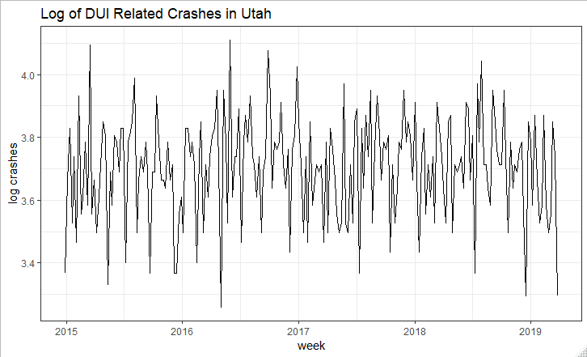

Visual inspection of this graph does not show a sudden drop in crashes in the beginning of 2019. Evaluating interventions without a randomized experiment can be a complicated process. Any analysis seeking to do so needs to take into account the trend or expectation of the series had there not been any treatment. This can be done using a Box Jenkins approach.

Walter Enders in “Applied Econometric Time Series” highlights several methods for studying the impact of an intervention or treatment on a time series. Intervention analysis allows a formal test of a change in the mean of a time series13. One such method is to incorporate an intervention function into an ARIMA model. For this data, the intervention function takes the form of an indicator function which returns a 1 for all weeks greater than 2018-12-30 and a zero otherwise. It is safe to assume that the .05 BAC law was well known and that the impact was immediate. Otherwise, we may consider an alternative intervention function that accounts for a gradual awareness and hence impact of the law. The following is a general form of the ARIMA with intervention equation:

*Yt = ao + A(L)yt-1 + cozt + B(L)Et*

Where A(L) and B(L) are polynomials in the lag order L and zt represents the indicator of the form I(date > ‘2018-12-30’).

Enders outlines the following steps for such an intervention analysis:

**Step 1:** Use the longest data span (i.e. either the pre- or the postintervention observations) to find a plausible set of ARIMA models. Ensure that the {yt} sequence is stationary. If the sequence is non-stationary you should perform unit root tests on the longest span.

**Step 2:** Estimate the various models over the entire sample period, including the effect of the intervention.

In our data, the effect is the indicator for before/after the .05 implementation.

**Step 3:** Perform Diagnostic checks of the estimated equations. This is particularly important since we’ve merged the observations from pre- and postintervention periods. The model chosen should have the following characteristics:

1. The coefficients should be of “high quality”. (i.e. statistically significant, convergent yt implied)
2. The residuals should be white noise
3. The model should outperform plausible alternatives

After performing these steps, the coefficient on the indicator will provide an estimate of the impact and difference in means post-intervention. If the coefficient is negative and statistically significant then the results indicate that the .05 law had a positive impact on DUI related crashes.

**Results**

Performing steps 1-3 resulted in the following:

1. In our study, the longest span is that from 2015-01-01 to 2018-12-30.

Any data following this span was removed from the dataset and the resulting series was stationary at its level using both the Augmented Dickey Fuller test -- including drift and using the BIC to select the lag length -- and the KPSS test. Using the same reduced dataset I selected 3 potential ARIMA models: ARIMA(0,0,1), ARIMA(2,0,1), ARIMA(2,0,2).

1. The intervention indicator was then added to the ARIMA as well as the post-intervention data and all 3 models were estimated.
2. The 3 models were checked for white noise residuals using the Box-Ljung Q statistic and all 3 failed to reject the null and were found to have WN errors. The models were then compared using the AIC, SBC, and significance of parameters. The ARIMA(0,0,2) was chosen based on the AR components of the model implying a convergent yt sequence.

|  |  |  |  |  |  |
| --- | --- | --- | --- | --- | --- |
| **Models Summary** | | | | |  |
| **ARIMA Order** | **AIC** | **SBC** | **Q-Statistic at 20 Lags (p-value)** | **Proportion of Sig. Parameters** | **Yt Convergence** |
| (0,0,1) | 174.76 | 161.15 | 0.48 | 1/2 | Y |
| (2,0,1) | 171.82 | 151.41 | 0.73 | 2/4 | N |
| (2,0,2) | 171.87 | 148.05 | 0.72 | 6/6 | N |

The outcome on the intervention indicator is what we’re most interested in. All 3 models resulted in a negative coefficient between -.059 and -.065. The ARIMA(0,0,1) results showed a coefficient of -.0597 and a p-value of .07 (1-sided). While not significant at the conventional 5% level, the effect size is still unlikely to have been found by chance. We must also take into account that there were only 13 observations and 1 Quarter of data post-intervention.

In general terms, the data shows that lowering the BAC has resulted in 6% fewer DUI related collisions in Q1 of 2019. It is important to note that all 3 estimated ARIMA models showed a similar effect size of equal (or lower) significance. This number also falls in line with results from prior research on the topic.

**Conclusion**

While data is still limited, early indicators show that the implementation of a 0.05 BAC limit in Utah has had a positive impact on DUI related collisions. The analysis shows a reduction in DUI related collisions by 6% (p-value: 0.07) in Q1 of 2019. This reduction does fall short of the expectation of estimates from other researchers. Fell and Scherer (2017) estimated that if a U.S. states lowered the BAC to .05 the national average decrease in DUI related fatalities would be 11.5%9.

Evidence in favor of a BAC limit of .05 is stacking up quickly. It has already shown to be effective in other industrialized countries including Canada and Austrailia14. Through both intervention and medical studies, it has been proven to be an effective method to reduce impaired driving. Furthermore, most of the U.S. public is behind lowering the BAC limit from .0814. Surveys show that most people would not drive after consuming 2-3 drinks within an hour which is what would be required to hit a 0.05 BAC14.

With Utah being the first U.S. adopters of the .05 limit, the evaluation of its impact will be crucial in determining if and when more states will follow.

**Strengths and Limitations**

More data is needed to say with confidence what the long-term impact of the policy will be. Ideally, a full year of post-intervention data should be used and should show a statistically significant reduction.

Additionally, in the case of any intervention study it is best to use some sort of control. Many authors used a difference in differences approach using neighboring states without any policy change as a suitable control. You could also argue that using within-state non-DUI related crashes could be a stronger control if you make the assumption that the policy has no impact on non-DUI crashes. If so, this would control for any other within-state changes that could have occurred in the same time frame.

Further, while DUI related crashes are not wanted, what we really want to determine is the life-saving effect of a .05 policy implementation. Most research in the area has been on this as opposed to crashes.

**Additional Charts**

|  |  |  |  |
| --- | --- | --- | --- |
| **Model Coefficients and Standard Errors** | | | |
|  | **ARIMA(0,0,1)** | **ARIMA(2,0,1)** | **ARIMA(2,0,2)** |
| **AR1 (SE)** |  | 0.4125 (0.36) | 1.25 (0.16) |
| **AR2** |  | -0.0213 (0.08) | -0.83 (0.14) |
| **MA1** | **-0.0992 (0.0725)** | 0.3586 (0.0089) | -1.32 (0.15) |
| **MA2** |  |  | 0.85 (0.14) |
| **post_dummy** | **-0.0595 (0.04)** | -0.062 (0.0382) | 0.0597 (0.04) |

|  |  |  |
| --- | --- | --- |
| **Unit Root Testing** | | |
|  | ADF Test | KPSS Test |
| Lag Selection | BIC | Bartlett Kernek |
| Type | Constant | Constant |
| Test Statistic | -11 | 0.14 |
| 5% Cuttoff | -2.88 | 46 |

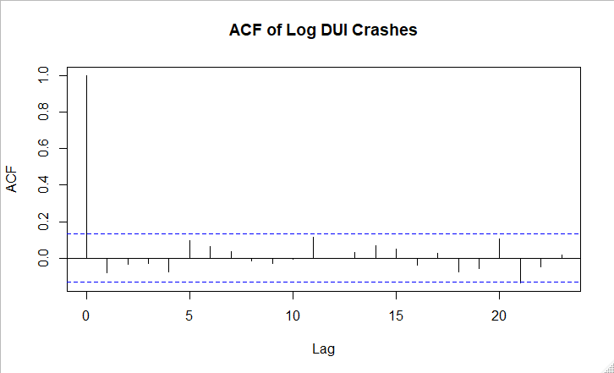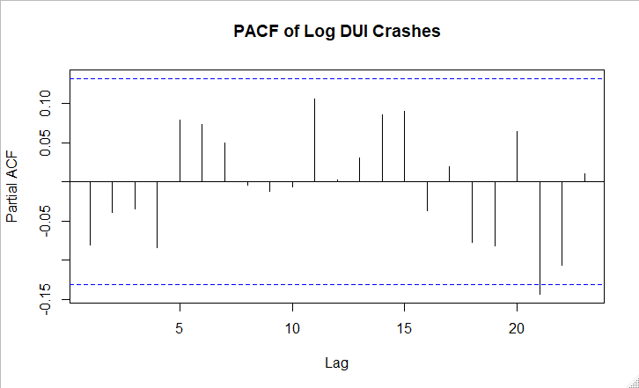

References:

1. National Highway Traffic Safety Administration. Traffic Safety Facts 2016 data: alcohol-impaired driving. U.S. Department of Transportation, Washington, DC; 2017 Available at: [https://crashstats.nhtsa.dot.gov/Api/Public/ViewPublication/812450External](https://crashstats.nhtsa.dot.gov/Api/Public/ViewPublication/812450) Accessed 16 April 2018.
2. <https://one.nhtsa.gov/About-NHTSA/Traffic-Techs/current/ci.State-Alcohol-Cost-Fact-Sheets-Document-The-Costs-Of-Impaired-Driving-For-Each-State.print>
3. <https://one.nhtsa.gov/people/injury/research/pub/alcohol-laws/08history/1_introduction.htm>
4. National Highway Traffic Safety Administration, 2005, and How to Control Your Drinking, WR Miller and RF Munoz, University of New Mexico, 1982.
5. <https://www.nap.edu/resource/24951/011718AlcoholImpairedDrivingHighlights.pdf>
6. National Academies of Sciences, Engineering, and Medicine. 2018. *Getting to zero alcohol-impaired driving fatalities: A comprehensive approach to a persistent problem*. Washington, DC: The National Academies Press. doi: <https://doi.org/10.17226/24951>.
7. Kaplan S, Prato CG. Impact of BAC limit reduction on different population segments: a Poisson fixed effect analysis. Accident Analysis & Prevention. 2007;39:1146–1154
8. Apsler R, Char AR, Harding WM, Klein TM. The effects of .08 BAC laws, in Series The effects of .08 BAC laws, U.S. Department of Transportation, National Highway Traffic Safety Administration; Washington, DC: 1999.
9. Fell JC, Scherer M. Estimation of the Potential Effectiveness of Lowering the Blood Alcohol Concentration (BAC) Limit for Driving from 0.08 to 0.05 Grams per Deciliter in the United States. *Alcohol Clin Exp Res*. 2017;41(12):2128–2139. doi:10.1111/acer.13501
10. Asbridge M, Cartwright J, Langille D. Driving under the influence of opioids among high school students in Atlantic Canada: prevalence, correlates, and the role of medical versus recreational consumption. Accident Analysis & Prevention. 2015;75:184–191.
11. Voas RB, Tippetts AS, Taylor EP. The Illinois .08 law: An evaluation. Journal of Safety Research. 2002;33:73–80. [[PubMed](https://www.ncbi.nlm.nih.gov/pubmed/11979638)] [[Google Scholar](https://scholar.google.com/scholar_lookup?journal=Journal+of+Safety+Research&title=The+Illinois+.08+law:+An+evaluation&author=RB+Voas&author=AS+Tippetts&author=EP+Taylor&volume=33&publication_year=2002&pages=73-80&pmid=11979638&)]
12. Henstridge J, Homel R, Mackay P. The long-term effects of random breath testing in four Australian states: a time series analysis, in Series The long-term effects of random breath testing in four Australian states: a time series analysis. Federal Office of Road Safety; Canberra, Australia: 1997
13. Enders, Walter, 1948Applied econometric time series / Walter, University of Alabama. – Fourth edition.
14. The effectiveness of a 0.05 blood alcohol concentration (BAC) limit for driving in the United States.

*Fell JC, Voas RB*

*Addiction. 2014 Jun; 109(6):869-74.*